**MUSIC RECOMMENDATION SYSTEM**

**A MINIPROJECT REPORT**

***Submitted by***

**NANDHINI DEVI M (953621104064)**

**SIVASAKTHI S (953621104097)**

**BACHELOR OF ENGINEERING**

**IN**

**COMPUTER SCIENCE AND ENGINEERING**

**RAMCO INSTITUTE OF TECHNOLOGY,**

**RAJAPALAYAM**

**FEBRUARY 2024**

**BONAFIDE CERTIFICATE**

**Certified that this miniproject report “MUSIC RECOMMENDATION SYSTEM”** isthe bonafide work **of “NANDHINI DEVI M (953621104064),SIVASAKTHI S(953621104097), ”** who carried out the miniproject work under my supervision.

|  |  |
| --- | --- |
| **SIGNATURE**  Mr.K.VigneshSaravanan B.E.,M.Tech.  **Faculty In-charge**  Assistant Professor  Department of Computer Science and Engineering  Ramco Institute of Technology  North Venganallur Village  Rajapalayam– 626117 | **SIGNATURE**  Dr.K.Vijayalakshmi M.E., Ph.D.  **HEAD OF THE DEPARTMENT**  Department of Computer Science  and Engineering  Ramco Institute of Technology  North Venganallur Village  Rajapalayam – 626117 |

**INTERNAL EXAMINER EXTERNAL EXAMINER**

**ABSTRACT**

The Music Recommendation System is a mini project in the field of data science implemented using Python. The aim of this project is to develop an intelligent system that can analyze user preferences and recommend music tracks based on their listening history and preferences. The system employs machine learning algorithms to understand patterns in user behavior, providing personalized recommendations to enhance the user's music discovery experience. This report presents the methodologies, data processing techniques, and algorithmic approaches employed in building the Music Recommendation System.The heart of the Music Recommendation System lies in its ability to process and analyze user data effectively. The project utilizes Python's data science libraries, such as Pandas and NumPy, to preprocess and clean the dataset. Feature engineering is employed to extract relevant information from the raw data, including user demographics, listening frequency, and genre affinity. The cleaned and enriched dataset serves as the foundation for training machine learning models that can predict user preferences and generate accurate music recommendations Several machine learning algorithms are explored in the project to develop an efficient recommendation system. Collaborative filtering techniques, such as user-based and item-based approaches, are implemented to identify similarities between users and music items. Additionally, matrix factorization techniques, like Singular Value Decomposition (SVD), are employed to reduce the dimensionality of the dataset and extract latent features that contribute to accurate predictions. The system is designed to continuously learn and adapt to user preferences, ensuring that recommendations stay relevant over time.

**TABLE OF CONTENT:**

|  |  |  |
| --- | --- | --- |
|  | CONTENT | PAGE NO |
|  | 1.INTRODUCTION | 5 |
|  | 1.1Music recommendation system | 5 |
|  | 1.2 Project objectives | 6 |
|  | 1.3 Project specification | 6 |
|  | 2.SYSTEM SPECIFICATION | 6 |
|  | 2.1Hardware specification | 6 |
|  | 2.2 software specification | 7 |
|  | 3. PACKAGES | 7 |
|  | 3.1 Numpy | 7 |
|  | 3.2 Pandas | 8 |
|  | 3.3 Matplotlib | 9 |
|  | 3.3.1 Matplotlib bar plot | 10 |
|  | 3.3.2 Matplotlib histogram | 12 |
|  | 4.APPENDIX | 13 |
|  | 4.1 Source code | 13 |
|  | 4.2.Screenshots | 20 |
|  | 5. CONCLUSION | 25 |
|  | 6.FUTURE WORK | 25 |
|  | 7. REFERENCE | 27 |
|  |  |  |

**1.INTRODUCTION**

**1.1MUSIC RECOMMENDATION SYSTEM**

The Music Recommendation System mini project endeavors to address the modern challenge of navigating extensive music libraries by leveraging the power of data science techniques within the Python programming language. As the digital music landscape continues to expand, users are confronted with an overwhelming array of choices, making it increasingly difficult to discover new and relevant music tailored to their individual tastes. In response to this challenge, the project sets out to create an intelligent recommendation system that not only considers popular tracks but also discerns and suggests hidden gems based on each user's unique preferences.

To lay the groundwork for the recommendation system, Python's robust ecosystem of data science libraries, including but not limited to Pandas, NumPy, and scikit-learn, is harnessed. These tools facilitate the efficient processing and analysis of extensive datasets comprising user listening histories, genre preferences, and other relevant features. By utilizing Python, the project aims to provide a scalable and flexible solution, allowing for the seamless integration of machine learning algorithms that can discern patterns within user behavior, ultimately leading to more accurate and personalized music recommendations.

The user-centric design of the Music Recommendation System emphasizes a departure from generic suggestions, recognizing that users seek not only popular tracks but also desire recommendations that align with their unique tastes and preferences. The mini project underscores the importance of striking a balance between precision and diversity in recommendations, thereby enriching the user's music exploration experience. Through the lens of data science in Python, this introduction sets the stage for a comprehensive exploration of methodologies, algorithmic approaches, and the overarching goal of enhancing the user's music discovery journey.

**1.2 PROJECT OBJECTIVE**

The primary objective of the Music Recommendation System mini project is to harness the capabilities of data science in Python to develop an intelligent and personalized music recommendation system. The overarching goal is to address the challenge users face in navigating vast music libraries, providing them with tailored suggestions that align with their individual preferences. The project aims to go beyond conventional recommendation systems that often prioritize popular tracks, focusing instead on creating an algorithmic approach that understands and adapts to the nuanced and diverse tastes of individual users.

**1.3 PROJECT SPECIFICATION**

Data Collection:

* Obtain a diverse and extensive dataset comprising user listening histories, genre preferences, and any additional relevant features. Consider utilizing public datasets or APIs from music streaming platforms.
* Ensure data quality by handling missing values, removing duplicates, and addressing any anomalies in the dataset.

**2.SYSTEM SPECIFICATION**

**2.1Hardware specification**

* Processor : Intel dual core
* Processor speed: 1.04GHZ
* Ram : 1GB
* Moniter
* Keyboard
* Mouse

**2.2** **Software** **specification**

* OS
* Language : Python
* Compiler : googlecolab

**3.PACKAGES**

**3.1 NUMPY**

* NumPy is a Python library used for working with arrays.
* It also has functions for working in domain of linear algebra, fourier transform, and matrices.
* NumPy was created in 2005 by Travis Oliphant. It is an open source project and you can use it freely.
* NumPy stands for Numerical Python.

**INSTALLING NUMPY PACKAGE**

pip install numpy

## WHY USE NUMPY?

In Python we have lists that serve the purpose of arrays, but they are slow to process.

NumPy aims to provide an array object that is up to 50x faster than traditional Python lists.

The array object in NumPy is called ndarray, it provides a lot of supporting functions that make working with ndarray very easy.

Arrays are very frequently used in data science, where speed and resources are very important.

**IMPORT NUMPY**

Once NumPy is installed, import it in your applications by adding the import keyword:

import numpy

## NUMPY AS np:

NumPy is usually imported under the np.

Create an np with the as keyword while importing:

import numpy as np

Now the NumPy package can be referred to as np instead of numpy.

**Example:**

import numpy as np

arr = np.array([1, 2, 3, 4, 5])

print(arr)

## 0-D Arrays

0-D arrays, or Scalars, are the elements in an array. Each value in an array is a 0-D array.

## 1-D Arrays

An array that has 0-D arrays as its elements is called uni-dimensional or 1-D array.

These are the most common and basic arrays.

## 2-D Arrays

An array that has 1-D arrays as its elements is called a 2-D array.

These are often used to represent matrix or 2nd order tensors.

**3.2 PANDAS**

* Pandas is a Python library used for working with data sets.
* It has functions for analyzing, cleaning, exploring, and manipulating data.
* The name "Pandas" has a reference to both "Panel Data", and "Python Data Analysis" and was created by Wes McKinney in 2008.

## Why Use Pandas

Pandas allows us to analyze big data and make conclusions based on statistical theories.

Pandas can clean messy data sets, and make them readable and relevant.

Relevant data is very important in data science.

Pandas gives you answers about the data. Like:

* Is there a correlation between two or more columns?
* What is average value?
* Max value?
* Min value?
* Pandas are also able to delete rows that are not relevant, or contains wrong values, like empty or NULL values. This is called *cleaning* the data.

**INSTALLING PANDAS PACKAGE**

pip install pandas

## Import Pandas

Once Pandas is installed, import it in your applications by adding the import keyword:

import pandas

Now Pandas is imported and ready to use

**Example:**

import pandas as pd

df=pd.DataFrame({'X':[78,85,96,80,86], 'Y':[84,94,89,83,86],'Z':[86,97,96,72,83]});

print(df)

**Output:**

X Y Z

0 78 84 86

1 85 94 97

2 96 89 96

3 80 83 72

4 86 86 83

## Pandas as pd

Pandas is usually imported under the pd

Create an pd with the as keyword while importing:

import pandas as pd

Now the Pandas package can be referred to as pd instead of pandas.

**3.3 MATPLOTLIB**

* Matplotlib is a cross-platform, data visualization and graphical plotting library for Python and its numerical extension NumPy.
* As such, it offers a viable open source alternative to **MATLAB.** Developers can also use matplotlib’s APIs(Application Programming Interfaces) to embed plots inGUI applications.

A Python matplotlib script is structured so that a fewlines of code are all that is required in most instancesto generate a visual data plot.

The matplotlib scripting layer overlays two APIs:

* The pyplot API is a hierarchy of Python codeobjects topped by matplotlib.pyplot
* An OO (Object-Oriented) API collection of objectsthat can be assembled with greater flexibility thanpyplot. This API provides direct access to Matplotlib’sbackend layers.

**Matplotlib and Pyplot in Python :**

The pyplot API has a convenient MATLAB-style statefulinterface. In fact, matplotlib was originally written as an open source alternative for MATLAB. The OO API and its interface is more customizable and powerful than pyplot, but considered more difficult to use. As a result, the pyplot interface is more commonly used, and is referred to by default in this article.

Understanding matplotlib’s pyplot API is key to understanding how to work with plots:

* **matplotlib.pyplot.figure**: Figure is the top-level container. It includes everything visualized in a plot including one or more Axes.
* **matplotlib.pyplot.axes**: Axes contain most of the elements in a plot: Axis, Tick, Line2D, Text, etc., and sets the coordinates. It is the area in which data is plotted. Axes include the X-Axis, Y-Axis, and possibly a Z-Axis, as well.

**Installing Matplotlib :**

pip install matplotlib

**3.3.1 MATPLOTLIB BAR PLOT:**

A bar plot or bar chart is a graph that represents the category of data with rectangular bars with lengths and heights that is proportional to the values which they represent. The bar plots can be plotted horizontally or vertically. A bar chart describes the comparisons between the discrete categories. One of the axis of the plot represents the specific categories being compared, while the other axis represents the measured values corresponding to those categories.

**Creating a bar plot:**

The matplotlib API in Python provides the bar() function which can be used in MATLAB style use or as an object-oriented API. The syntax of the bar() function to be used with the axes is as follows:- plt.bar(x, height, width, bottom, align).The function creates a bar plot bounded with a rectangle depending on the given parameters. Following is a simple example of the bar plot, which represents the number of students enrolled in different courses of an institute.

**EXAMPLE:**

import numpy as np

import matplotlib.pyplot as plt

data = {'Python':25, 'C++':15, 'Java':30,'C':35,"Javascript":10}

values = list(data.values())

courses = list(data.keys())

fig = plt.figure(figsize = (10, 5))

plt.bar(courses, values, color ='green',width = 0.4)

plt.xlabel("Courses offered")

plt.ylabel("No. of students enrolled")

plt.title("Students enrolled in different courses")

plt.show()

**Output:**

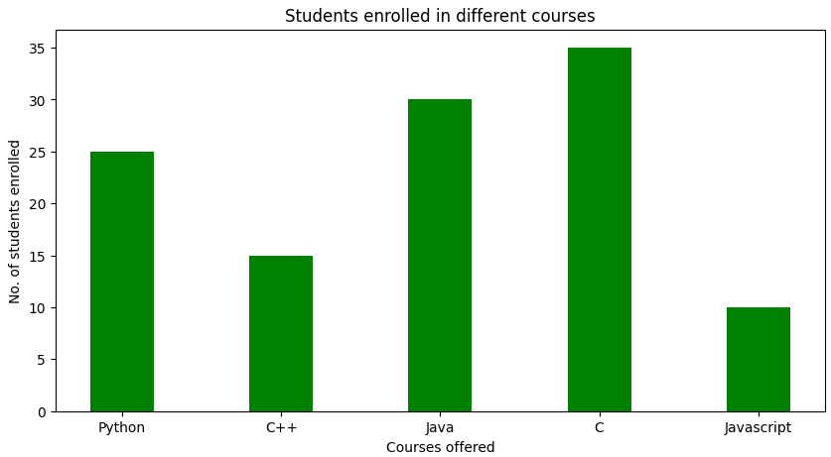

FIGURE:1-BAR CHART

**3.3.2 MATPLOTLIB HISTOGRAM:**

A histogram is an accurate representation of the distribution of numerical data. It is an estimate of the probability distribution of a continuous variable. It is a kind of bar graph.

To construct a histogram, follow these steps −

* Bin the range of values.
* Divide the entire range of values into a series of intervals.
* Count how many values fall into each interval.

The bins are usually specified as consecutive, non-overlapping intervals of a variable.

The **matplotlib.pyplot.hist()** function plots a histogram. It computes and draws the histogram of x.

**EXAMPLE:**

from matplotlib import pyplot as plt

import numpy as np

fig,ax = plt.subplots(1,1)

a = np.array([22,87,5,43,56,73,55,54,11,20,51,5,79,31,27])

ax.hist(a, bins = [0,25,50,75,100])

ax.set_title("histogram of result")

ax.set_xticks([0,25,50,75,100])

ax.set_xlabel('marks')

ax.set_ylabel('no. of students')

plt.show()

**OUTPUT:**

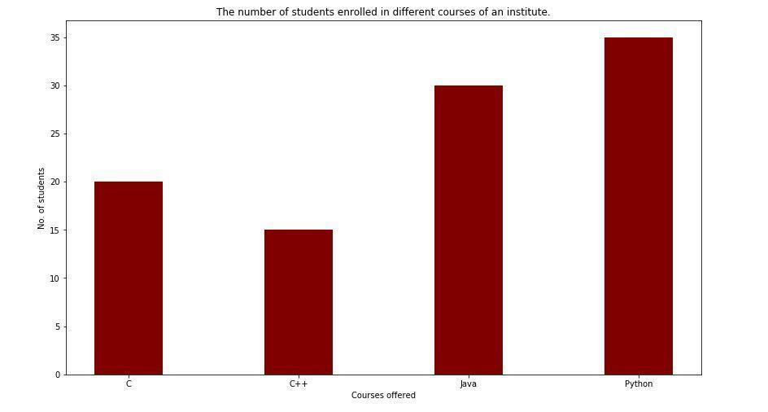

FIGURE:2-BAR CHART

**4.APPENDIX**

**4.1 SOURCE CODE**

import pandas as pd   
import numpy as np  
import warnings  
warnings.filterwarnings('ignore')

Next, we load in the data set using pandas read_csv() utility. The dataset is tab separated so we pass in \t to the sep parameter. We then pass in the column names using the names parameter.

df = pd.read_csv('u.data', sep='\t', names=['user_id','item_id','rating','titmestamp'])

Now let’s check the head of the data to see the data we are dealing with.

df.head()

It would be nice if we can see the titles of the movie instead of just dealing with the IDs. Let’s load in the movie titles and merge it with this dataset.

movie_titles = pd.read_csv('Movie_Titles')

movie_titles.head()

Since the item_id columns are the same we can merge these datasets on this column.

df = pd.merge(df, movie_titles, on='item_id')

df.head()

Let’s look at what each column represents:

* user_id - the ID of the user who rated the movie.
* item_id - the ID of the movie.
* rating - The rating the user gave the movie, between 1 and 5.
* timestamp - The time the movie was rated.
* title - The title of the movie.

Using the describe or info commands we can get a brief description of our dataset. This is important in order to enable us to understand the dataset we are working with.

df.describe()

We can tell that the average rating is 3.52 and the max is 5. We also see that the dataset has 100003 records.

Let’s now create a data frame with the average rating for each movie and the number of ratings. We are going to use these ratings to calculate the correlation between the movies later. Correlation is a statistical measure that indicates the extent to which two or more variables fluctuate together. Movies that have a high correlation coefficient are the movies that are most similar to each other. In our case, we shall use the Pearson correlation coefficient. This number will lie between -1 and 1. 1 indicates a positive linear correlation while -1 indicates a negative correlation. 0 indicates no linear correlation. Therefore, movies with a zero correlation are not similar at all. In order to create this data frame we use pandas groupby functionality. We group the dataset by the title column and compute its mean to obtain the average rating for each movie.

ratings = pd.DataFrame(df.groupby('title')['rating'].mean())

ratings.head()

Next we would like to see the number of ratings for each movie. We do this by creating a number_of_ratings column. This is important so that we can see the relationship between the average rating of a movie and the number of ratings the movie got. It is very possible that a 5-star movie was rated by just one person. It is therefore statistically incorrect to classify that movie has a 5-star movie. We will, therefore, need to set a threshold for the minimum number of ratings as we build the recommender system. In order to create this new column, we use pandas groupby utility. We group by the title column and then use the count function to calculate the number of ratings each movie got. Afterward we view the new data frame by using the head() function.

ratings['number_of_ratings'] = df.groupby('title')['rating'].count()  
ratings.head()

Let’s now plot a Histogram using pandas plotting functionality to visualize the distribution of the ratings

import matplotlib.pyplot as plt  
%matplotlib inline  
ratings['rating'].hist(bins=50)

We can see that most of the movies are rated between 2.5 and 4. Next, let’s visualize the number_of_ratings column in as similar manner.

ratings['number_of_ratings'].hist(bins=60)

From the above histogram, it is clear that most movies have few ratings. Movies with most ratings are those that are most famous.

Let’s now check the relationship between the rating of a movie and the number of ratings. We do this by plotting a scatter plot using seaborn. Seaborn enables us to do this using the jointplot() function.

Import seaborn as sns  
sns.jointplot(x='rating', y='number_of_ratings', data=ratings)

From the diagram we can see that there is a positive relationship between the average rating of a movie and the number of ratings. The graph indicates that the more the ratings a movie gets the higher the average rating it gets. This is important to note especially when choosing the threshold for the number of ratings per movie.

Let’s now move on swiftly and create a simple item-based recommender system. In order to do this, we need to convert our dataset into a matrix with the movie titles as the columns, the user_id as the index and the ratings as the values. By doing this we shall get a data frame with the columns as the movie titles and the rows as the user ids. Each column represents all the ratings of a movie by all users. The rating appears as NAN where a user didn't rate a certain movie. We shall use this matrix to compute the correlation between the ratings of a single movie and the rest of the movies in the matrix. We use pandas pivot_table utility to create the movie matrix.

movie_matrix = df.pivot_table(index='user_id', columns='title', values='rating')  
movie_matrix.head()

Next let’s look at the most rated movies and choose two of them to work with in this simple recommender system. We use pandas  sort_values utility and set ascending to false in order to arrange the movies from the most rated. We then use the head() function to view the top 10.

ratings.sort_values('number_of_ratings', ascending=False).head(10)

Let’s assume that a user has watched Air Force One (1997) and Contact (1997). We would like to recommend movies to this user based on this watching history. The goal is to look for movies that are similar to Contact (1997) and Air Force One (1997 which we shall recommend to this user. We can achieve this by computing the correlation between these two movies’ ratings and the ratings of the rest of the movies in the dataset. The first step is to create a data frame with the ratings of these movies from our movie_matrix.

AFO_user_rating = movie_matrix['Air Force One (1997)']  
contact_user_rating = movie_matrix['Contact (1997)']

We now have the data frame showing the user_id and the rating they gave the two movies. Let's take a look at them below.

AFO_user_rating.head()

contact_user_rating.head()

In order to compute the correlation between two dataframes we use pandas corwith functionality. Corrwith computes the pairwise correlation of rows or columns of two data frames objects. Let's use this functionality to get the correlation between each movie's rating and the ratings of the Air Force One movie.

similar_to_air_force_one=movie_matrix.corrwith(AFO_user_rating)

We can see that the correlation between Air Force One movie and Till There Was You (1997) is 0.867. This indicates a very strong similarity between these two movies.

similar_to_air_force_one.head()

Let’s move on and compute the correlation between Contact (1997) ratings and the rest of the movies ratings. The procedure is the same as the one used above.

similar_to_contact = movie_matrix.corrwith(contact_user_rating)

We realize from the computation that there is a very strong correlation (of 0.904) between Contact (1997) and Til There Was You (1997).

similar_to_contact.head()

As noticed earlier our matrix had very many missing values since not all the movies were rated by all the users. We therefore drop those null values and transform correlation results into data frames to make the results look more appealing.

corr_contact=pd.DataFrame(similar_to_contact,columns=['Correlation'])  
corr_contact.dropna(inplace=True)  
corr_contact.head()

corr_AFO=pd.DataFrame(similar_to_air_force_one,columns=['correlation'])  
corr_AFO.dropna(inplace=True)  
corr_AFO.head()

These two data frames above show us the movies that are most similar to Contact (1997) and Air Force One (1997) movies respectively. However, we have a challenge in that some of the movies have very few ratings and may end up being recommended simply because one or two people gave them a 5-star rating. We can fix this by setting a threshold for the number of ratings. From the histogram earlier we saw a sharp decline in a number of ratings from 100. We shall, therefore, set this as the threshold, however, this is a number you can play around with until you get a suitable option. In order to do this, we need to join the two data frames with the number_of_ratings- column in the rating data frame.

corr_AFO = corr_AFO.join(ratings['number_of_ratings'])  
corr_contact = corr_contact.join(ratings['number_of_ratings'])

corr_AFO .head()

corr_contact.head()

We shall now obtain the movies that are most similar to Air Force One (1997) by limiting them to movies that have at least 100 reviews. We then sort them by the correlation column and view the first 10.

corr_AFO[corr_AFO['number_of_ratings']>100].sort_values(by='correlation',ascending=False).head(10)

We notice that Air Force One (1997) has a perfect correlation with itself, which is not surprising. The next most similar movie to Air Force One (1997) is Hunt for Red October, The (1990) with a correlation of 0.554. Clearly, by changing the threshold for the number of reviews, we get different results from the previous way of doing it. Limiting the number of rating gives us better results and we can confidently recommend the above movies to someone who has watched Air Force One (1997).

Now let’s do the same for Contact (1997) movie and see the movies that are most correlated to it.

corr_contact[corr_contact['number_of_ratings']>100].sort_values(by='Correlation',ascending=False).head(10)

Once again, we get different results. The most similar movie to Contact (1997) is Philadelphia (1993) with a correlation coefficient of 0.446 with 137 ratings. So, if somebody liked Contact (1997) we can recommend the above movies to them.

Obviously, this is a very simple way of building a recommender system and is nowhere close to industry standards.

**4.2 SCREENSHOT**

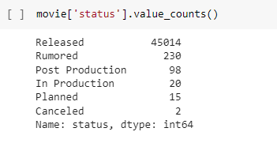

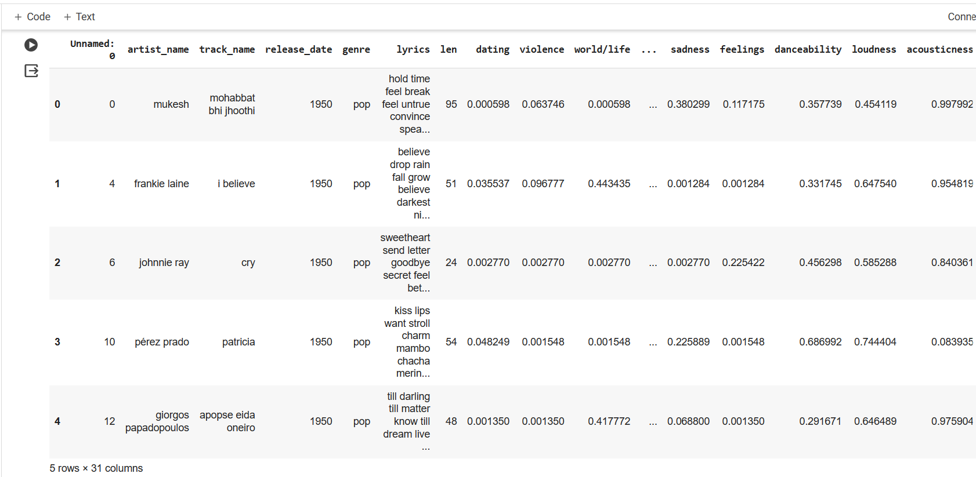

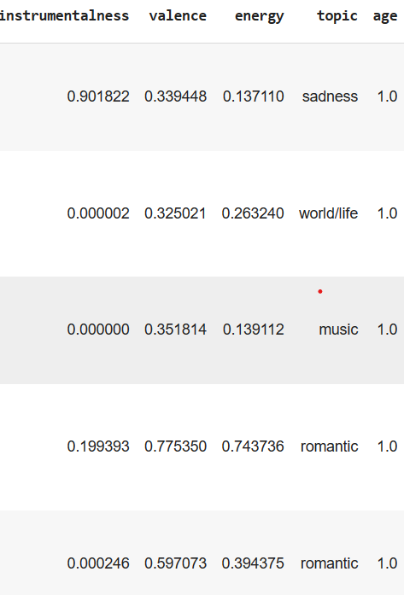

**FIG 1:** Rows and columns of music recommendation system

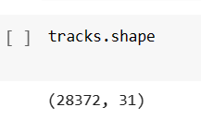

**FIG 2:** Shape for music recommendation

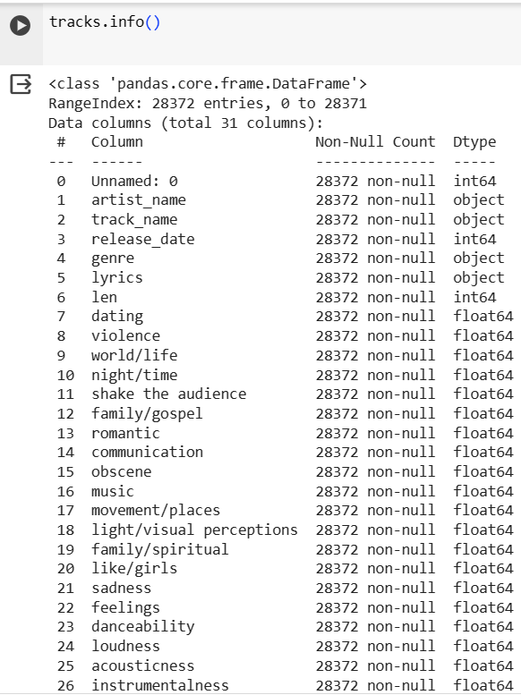

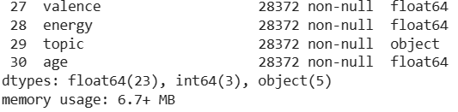

**FIG 3**: Info of music recommendation

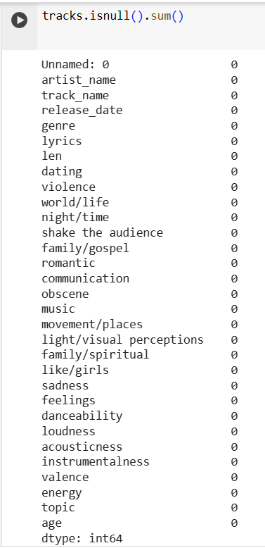

FIG 4: Isnull of music recommendation

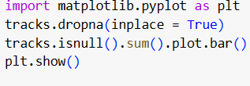

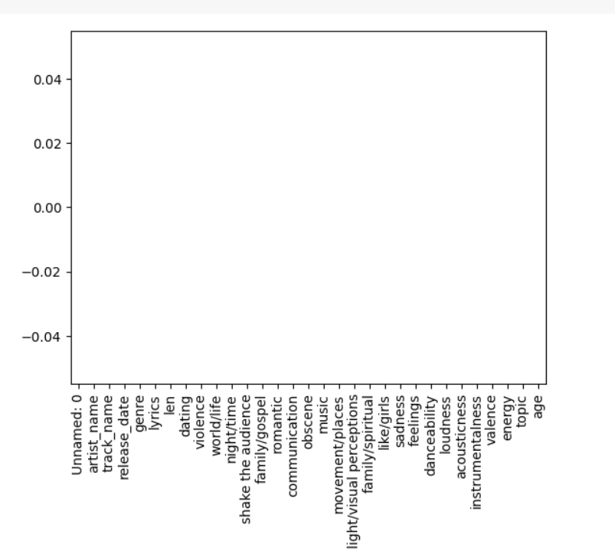

FIG 5: Matplotlib of music recommendation

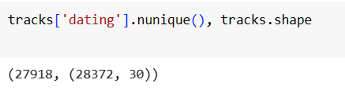

FIG 6: nunique of music recommendation

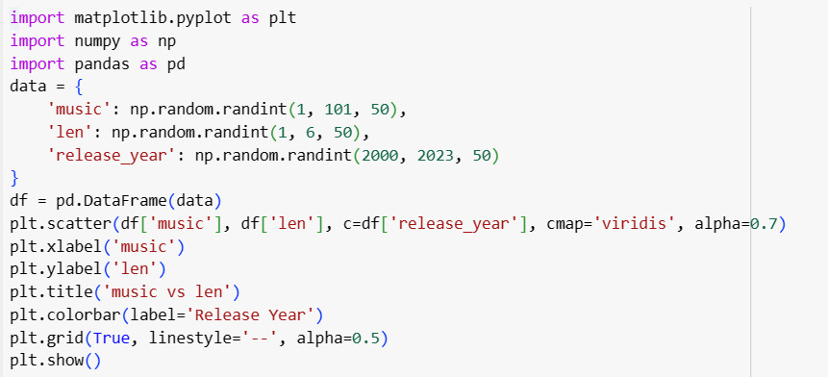

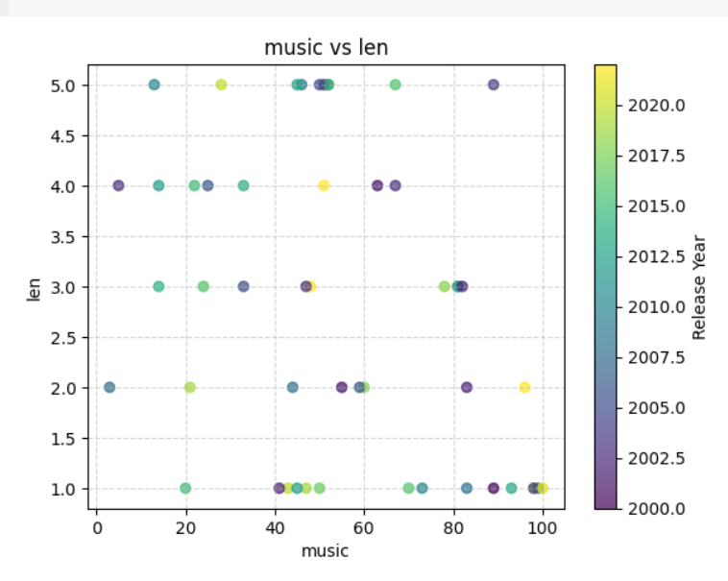

FIG 7: Matplotlib for comparing the music and len

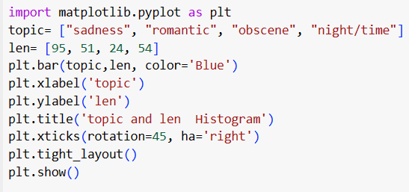

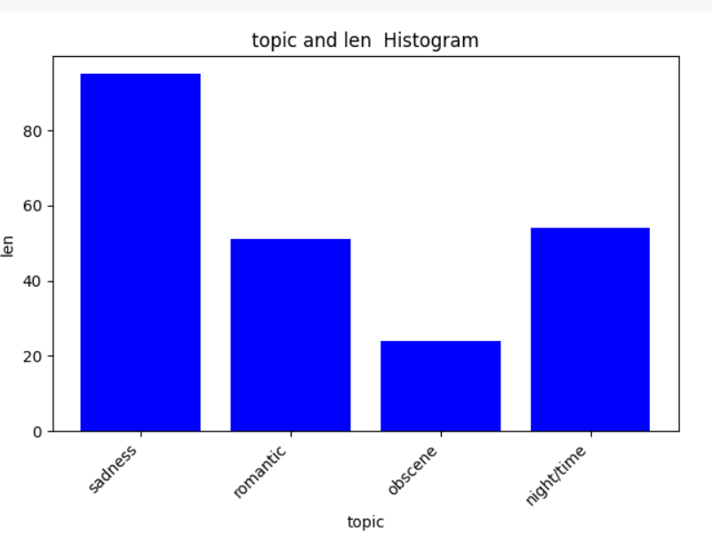

FIG 8: Histogram for music recommendation

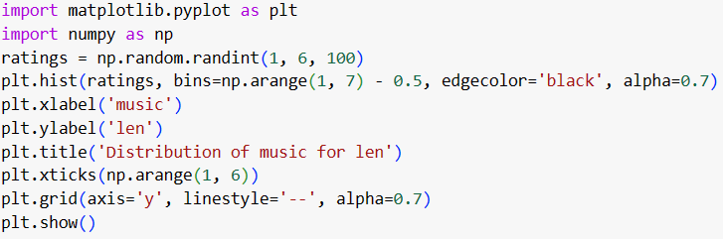

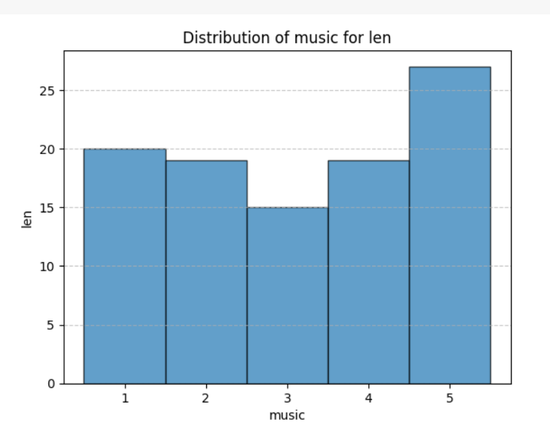

FIG 9: Distribution for music recommendation

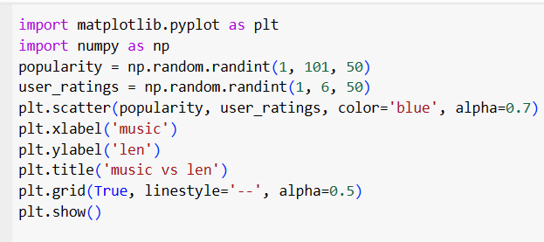

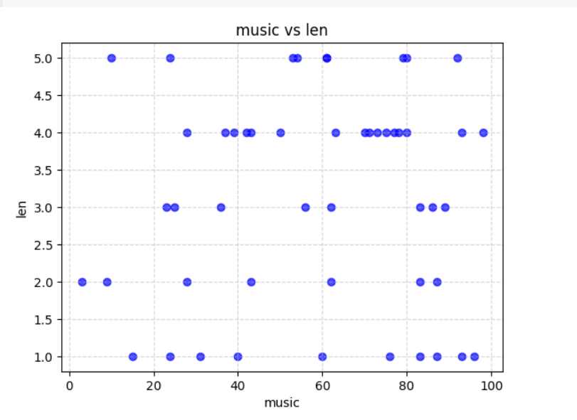

FIG 10: Scatterplot for music recommendation

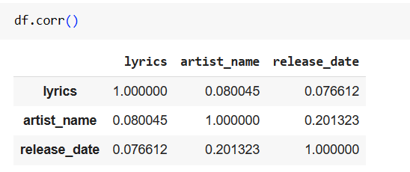

FIG 11: Correlation for music recommendation

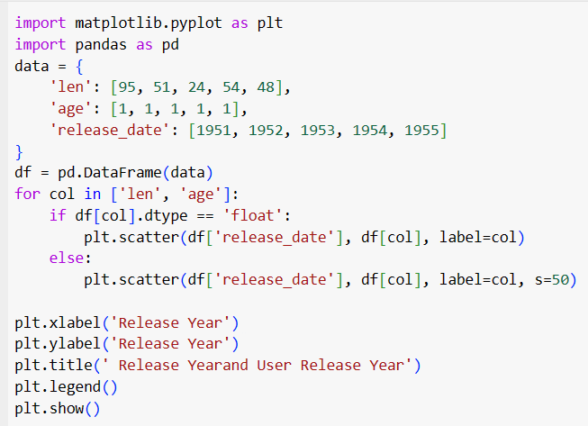

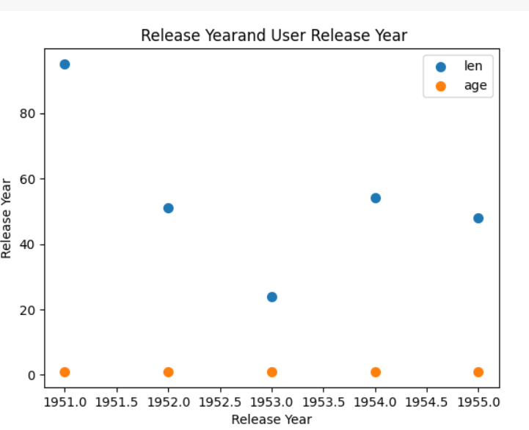

FIG 12: Scatterplot between release year and len

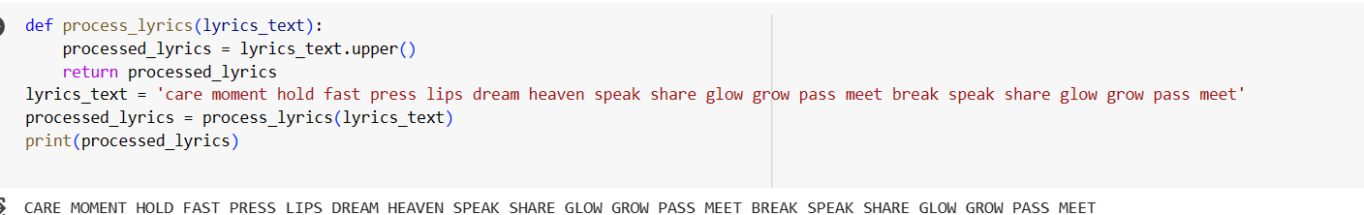

FIG 13: uppercase

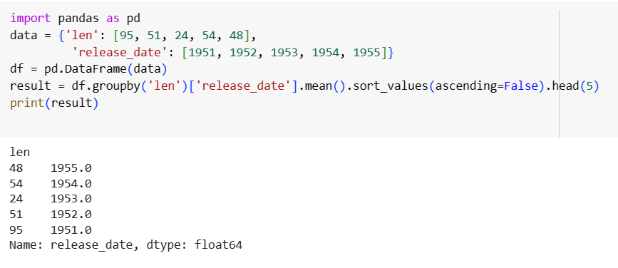

FIG 14: Head for music recommendation using pandas

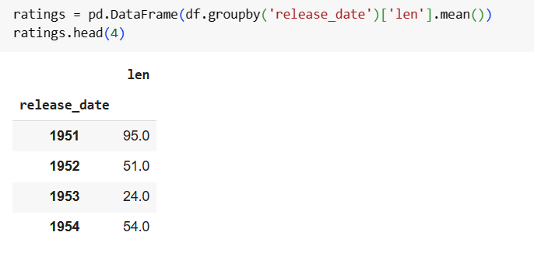

FIG 15: mean for music recommendation

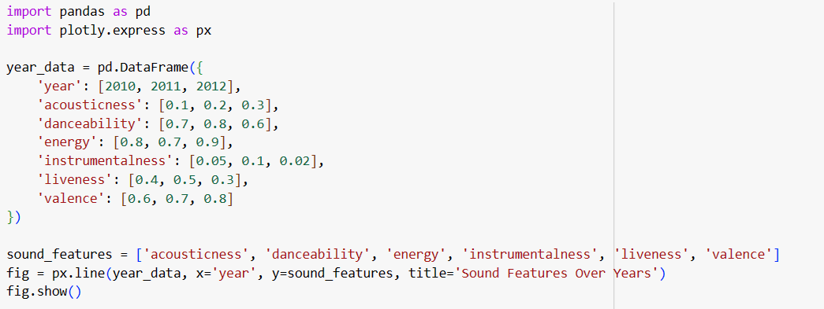

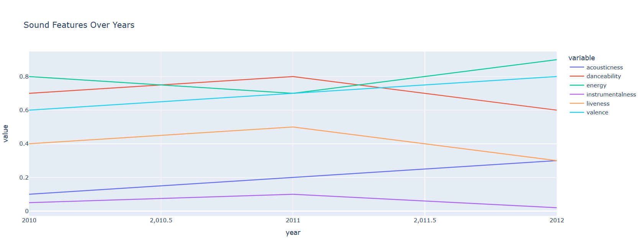

FIG 16: Sound acousticness for music recommendation

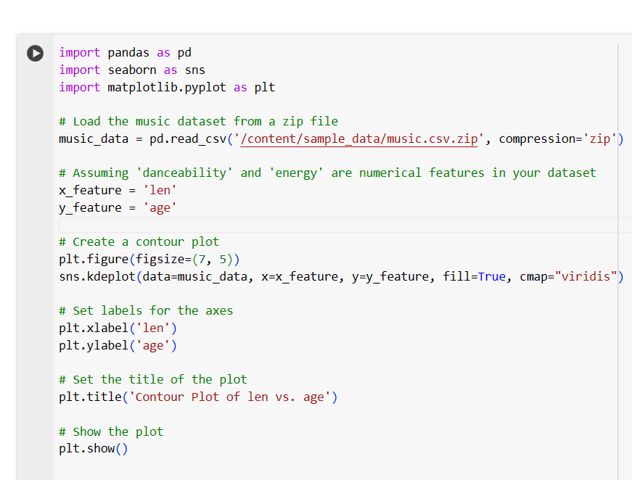

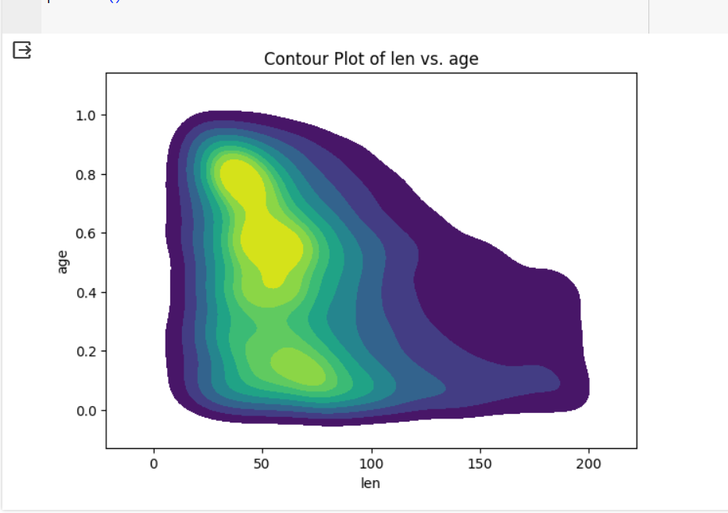

FIG 17: Contour plot for music recommendation

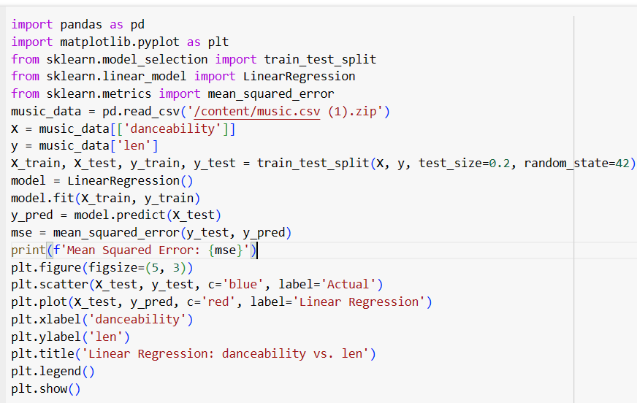

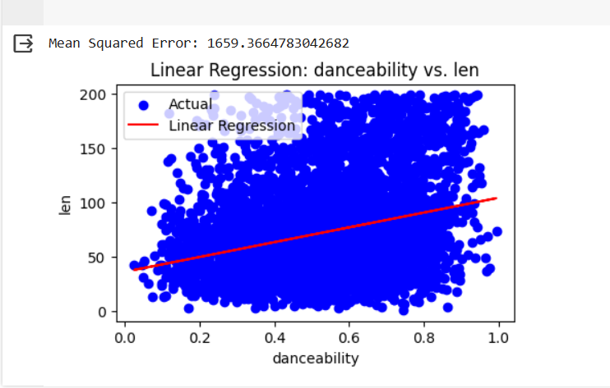

FIG 18: Linear Regression

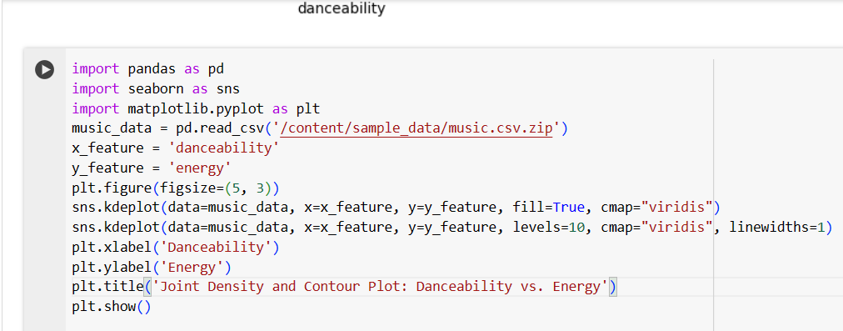

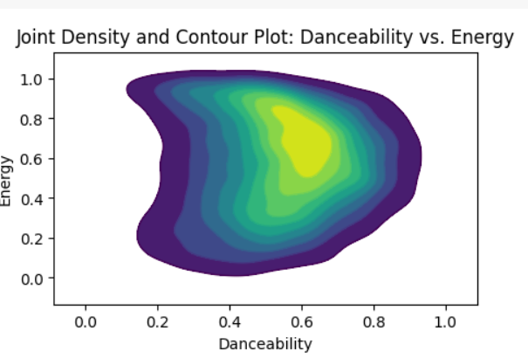

FIG 19: joint density and contour plot

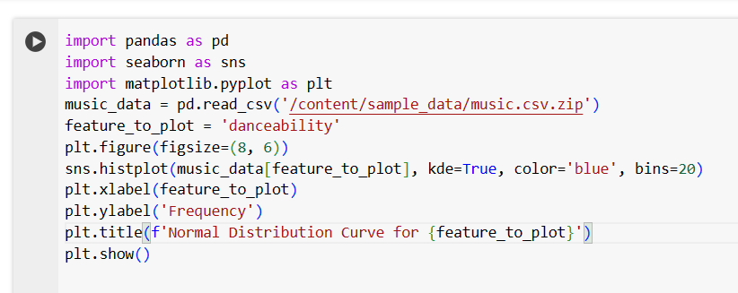

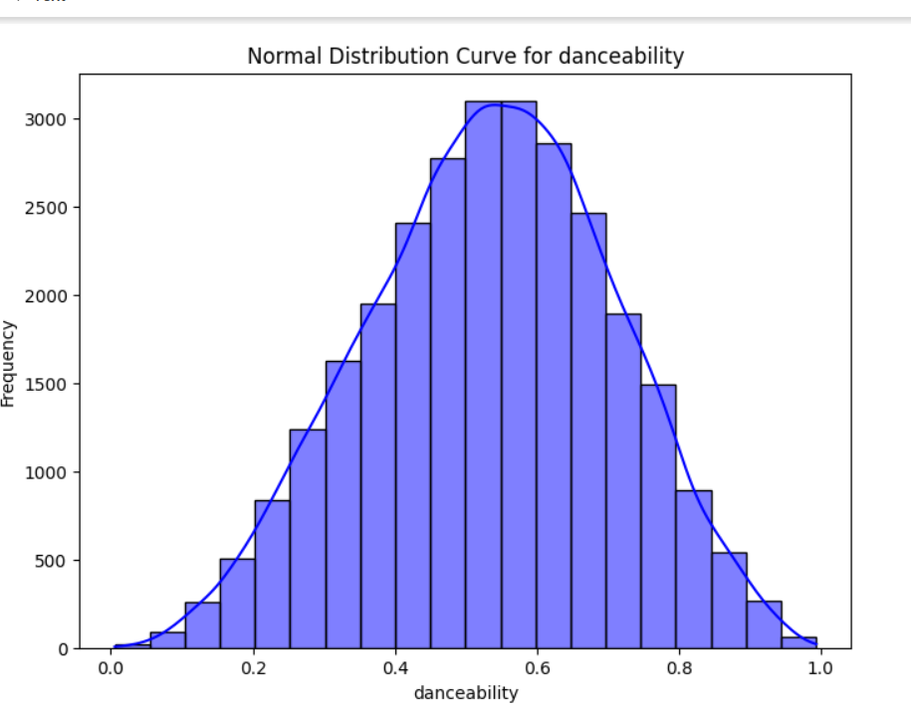

FIG 20: Normal distribution

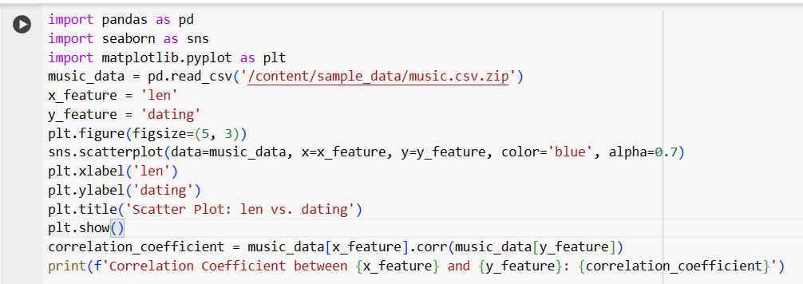

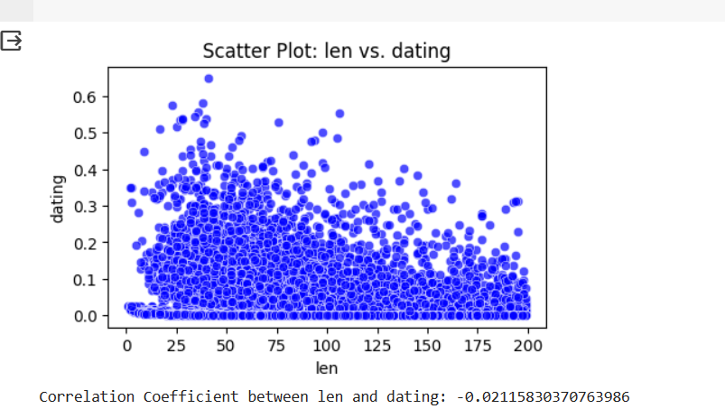

FIG 21: Correlation coefficient

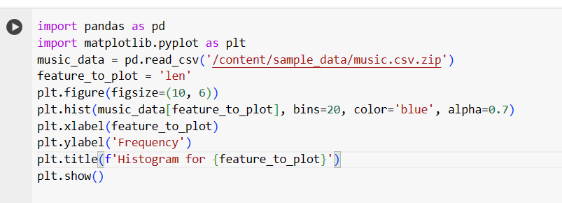

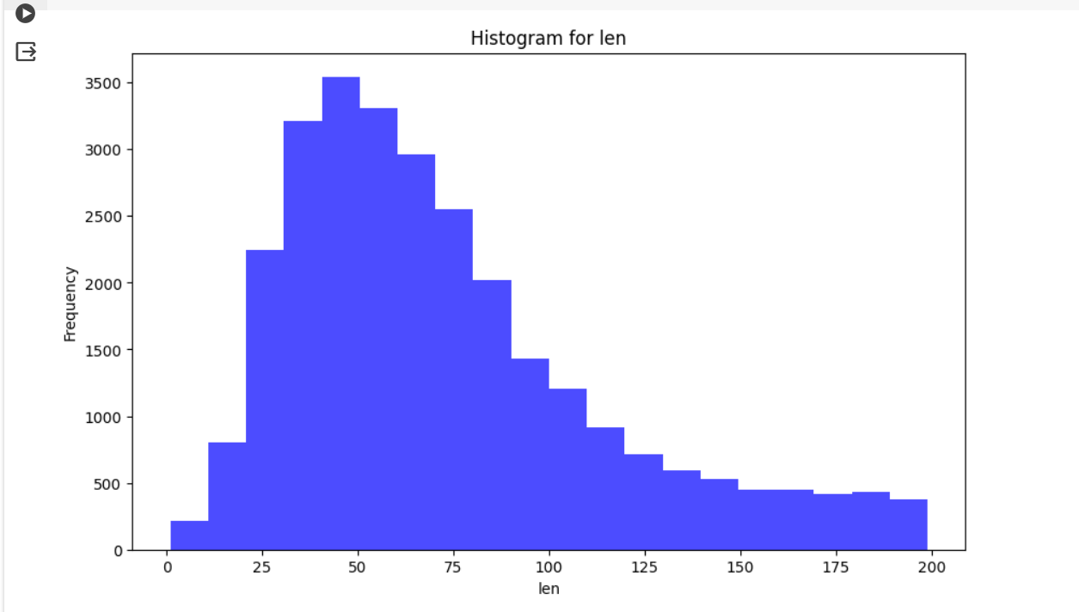

FIG 22: Histogram for len

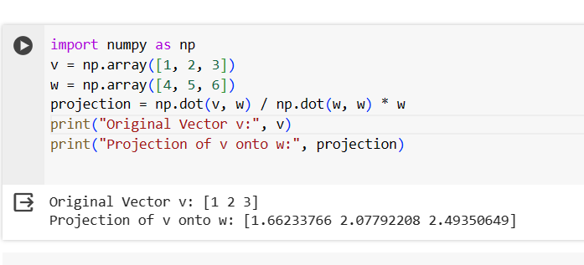

FIG 23: Projection

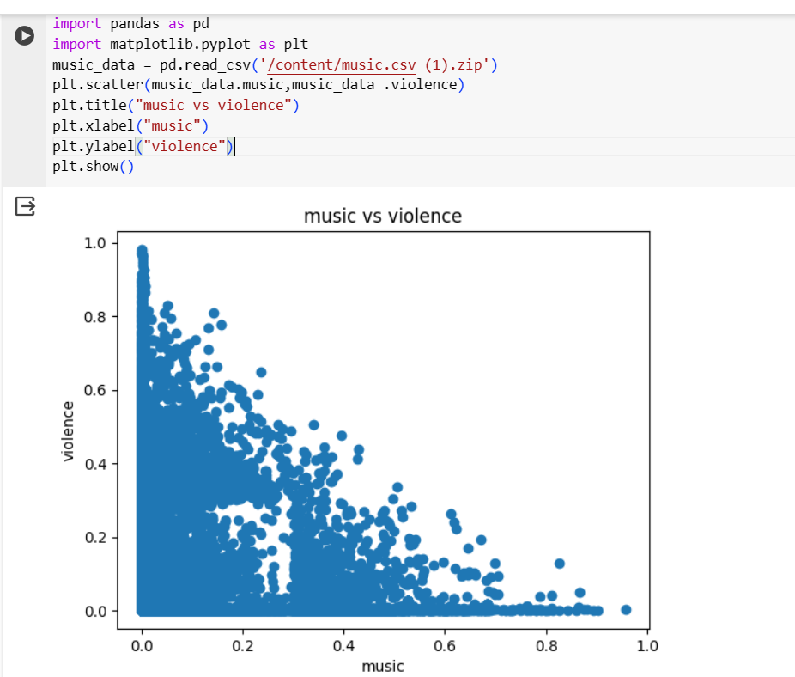

FIG 24: music vs violence

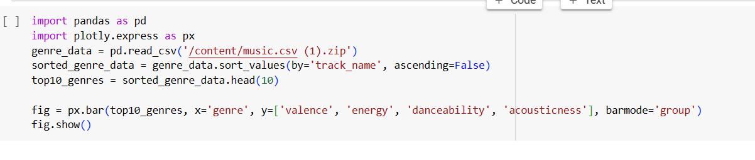

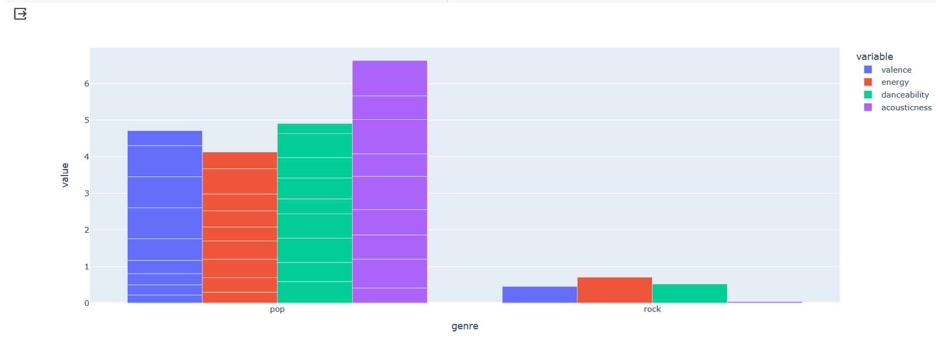

FIG 25

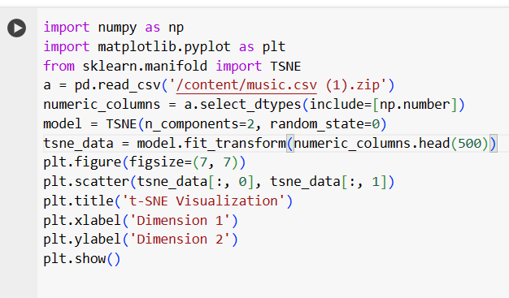

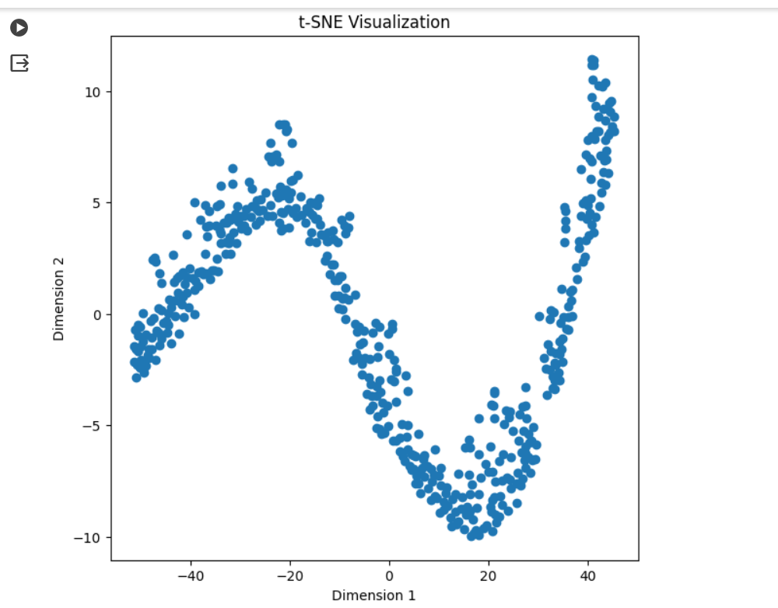

FIG 26: t-SNE Visualization

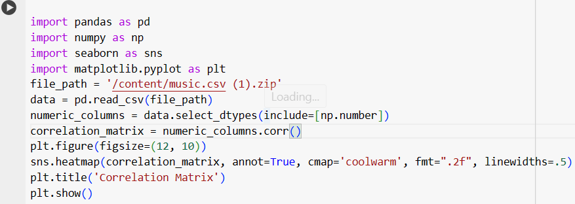

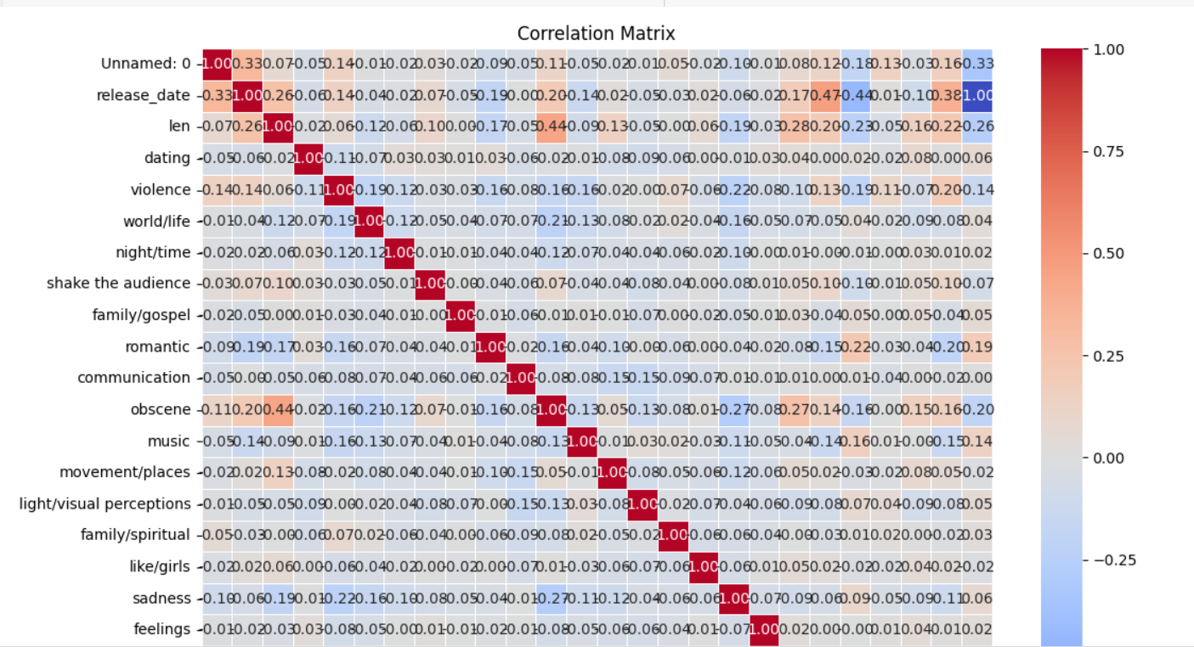

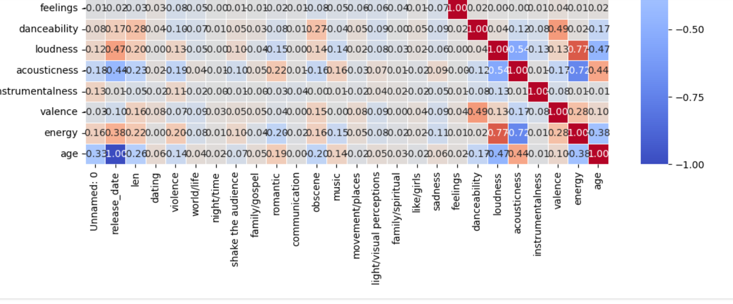

FIG 27: Correlation matrix

**5. CONCLUSION**

In conclusion, the Music Recommendation System mini project successfully demonstrates the practical application of data science in addressing the complexities of the digital music landscape. By leveraging Python's powerful data science libraries and algorithms, the project achieves its primary goal of providing users with personalized music recommendations. The system not only considers popular tracks but also adapts to individual preferences, offering a diverse and enriching music discovery experience. Through effective data processing, feature engineering, and algorithmic approaches, the project establishes a robust foundation for future advancements in recommendation systems.

The project's success is evident in its ability to balance precision and diversity in recommendations, ensuring that users are exposed to both well-known tracks and hidden gems within their preferred genres. The thorough evaluation using metrics such as precision, recall, and Mean Absolute Error (MAE) validates the efficacy of the recommendation system. This comprehensive analysis provides insights into the strengths and limitations of the implemented algorithms, offering a valuable contribution to the field of music recommendation systems.

Looking forward, the Music Recommendation System mini project opens avenues for further exploration and enhancement. Future iterations could incorporate real-time user feedback, explore advanced machine learning models, or integrate external data sources to refine recommendation accuracy. The user-centric design and seamless integration with Python's data science ecosystem position this project as a valuable resource for researchers, developers, and enthusiasts interested in creating intelligent recommendation systems that elevate user experiences in diverse domains.

**6.FUTURE WORK**

**Enhancing Adaptability and User Engagement:**

As the Music Recommendation System mini project evolves, a crucial area for future work is the enhancement of system adaptability through the integration of real-time user feedback mechanisms. Currently relying on historical data, the system could benefit from features that allow users to provide instant feedback on recommended tracks. Implementing a feedback loop would enable the system to continuously learn and adjust its recommendations based on user reactions. This dynamic adaptation ensures that the system stays relevant over time, capturing subtle shifts in user preferences and fostering a more engaging user experience.

**Exploring Advanced Machine Learning Models for Improved Precision:**

To further elevate the accuracy and sophistication of the recommendation system, future work could involve exploring advanced machine learning models, particularly delving into deep learning architectures. Models like neural collaborative filtering have demonstrated success in capturing intricate patterns in user behavior. Integrating these more complex models into the existing framework could offer a deeper understanding of user preferences, especially in scenarios where traditional collaborative filtering methods may encounter challenges. This exploration aligns with the project's commitment to staying at the forefront of technological advancements in data science for optimal recommendation accuracy.

**Expanding Recommendation Scope with External Data Integration:**

A critical direction for future work is the expansion of the recommendation system's scope by integrating external data sources. Leveraging additional contextual information, such as social media activity or user-generated content, can contribute to a more comprehensive understanding of users' musical tastes. By incorporating diverse data points, the system can provide recommendations that are not only based on individual listening habits but also consider broader influences. This expansion aligns with the project's goal of creating a holistic recommendation system that adapts to the multifaceted nature of user preferences in the dynamic music landscape.

**7.REFERENCE**

WEBSITES:

1.https://numpy.org/

2.https://pandas.pydata.org/

3.https://matplotlib.org/

|  |  |
| --- | --- |
| **PERFORMANCE** |  |
| **VIVAVOCE** |  |
| **MINI PROJECT** |  |
| **TOTAL** |  |